

Sustainable Development Strategy SDS symbolizes the roadmap for maximizing competitive benefit to achieve the thoughts and aspirations of Egyptians in a decent life.

It also denotes an example of the new constitution’s essence, setting wellbeing and wealth as the main economic objectives, to be achieved via sustainable development, social justice and a balanced, geographical and sectoral growth.

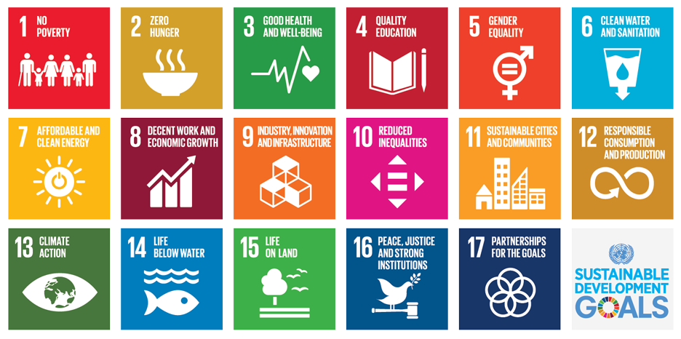s

At our university, BSU, last year we achieved most of the goals and we were ranked 201-300 worldwide (THE impact ranking)

Based on our distinguished research tracks and uniqueness of our faculty (PSAS) as a prototype of research educational platform that was funded at 2013, we already follow the SDGs as we have 4 departments: environmental science and industrial development- Renewabe science and Engineering- Biotechnology and life science-materials science and nanotechnology.

Please tick in front of the SDG that is tackled through the proposal as SDG 17 is mandatory + any two of the SDGs

The 17 sustainable development goals (SDGs) to transform our world:

[GOAL 1: No Poverty](https://www.un.org/development/desa/disabilities/?page_id=6226&preview=true)

[GOAL 2: Zero Hunger](http://www.un.org/development/desa/disabilities/envision2030-goal2.html)

[GOAL 3: Good Health and Well-being](http://www.un.org/development/desa/disabilities/envision2030-goal3.html)

[GOAL 4: Quality Education](http://www.un.org/development/desa/disabilities/envision2030-goal4.html)

[GOAL 5: Gender Equality](http://www.un.org/development/desa/disabilities/envision2030-goal5.html)

[GOAL 6: Clean Water and Sanitation](http://www.un.org/development/desa/disabilities/envision2030-goal6.html)

[GOAL 7: Affordable and Clean Energy](http://www.un.org/development/desa/disabilities/envision2030-goal7.html)

[GOAL 8: Decent Work and Economic Growth](http://www.un.org/development/desa/disabilities/envision2030-goal8.html)

[GOAL 9: Industry, Innovation and Infrastructure](http://www.un.org/development/desa/disabilities/envision2030-goal9.html)

[GOAL 10: Reduced Inequality](http://www.un.org/development/desa/disabilities/envision2030-goal10.html)

[GOAL 11: Sustainable Cities and Communities](http://www.un.org/development/desa/disabilities/envision2030-goal11.html)

[GOAL 12: Responsible Consumption and Production](http://www.un.org/development/desa/disabilities/envision2030-goal12.html)

[GOAL 13: Climate Action](http://www.un.org/development/desa/disabilities/envision2030-goal13.html)

[GOAL 14: Life Below Water](http://www.un.org/development/desa/disabilities/envision2030-goal14.html)

[GOAL 15: Life on Land](http://www.un.org/development/desa/disabilities/envision2030-goal15.html)

[GOAL 16: Peace and Justice Strong Institutions](http://www.un.org/development/desa/disabilities/envision2030-goal16.html)

[GOAL 17: Partnerships to achieve the Goal](http://www.un.org/development/desa/disabilities/envision2030-goal17.html) (regional- national- international) collaborations and funds (submitted projects- accepted)

**Template for Research Proposal**

**Thesis Title:**

**Student name:**

**Supervising Committee:**

The following is the minimum content required in the Research Proposal to be submitted to PSAS when requesting admission to the M.Sc. and/or Ph.D. In the case where the student’s research is being carried out in the context of a larger research programme, the research proposal should primarily focus on the student’s individual project and, except to put the student’s project in context, not on the larger research programme.

1. **Abstract (250 words)**

Summarise the objectives, the expected originality and the research methodology to be used.

1. **Research Contribution to the Research Field**

Describe the broad context of the research and the overall contribution which will be made to the general field of research.

1. **Objectives**

Summarise the key objectives of the research.

1. **Review of the state of the art, current literature in the field of research**

Review the state of the art literature/current practice in the topic of the proposed research with references to reported literature as appropriate.

1. **Expected progress with respect to the state of the art/ current literature/current practice in the field of research**

Progress must be described and possible outcomes ( publications and/or patents)

1. **Research methodology**

Describe the methodology to be used in the proposed research and why it is appropriate to the research objectives. If there are preliminary results please mention

1. **Work Plan**

Present the research work plan, outlining the main research tasks and timing. Include a simple Gantt chart

1. **Ethical issues**

If the proposed research directly involves human or live animal subjects, discuss the ethical issues involved and the actions that will be taken to ensure compliance with ethics guidelines.